KAILYARD DIARY REPORTS – 2024

MONTH | NAME | DATE VISITED | COMMENTS | WORK REQUIRED | DONE  √
Jan - Feb | Colin Miller, Barry Foster, Jo Vergunst | 02/02/24 | We carried out some winter jobs in the kailyard, on a beautiful sunny day.  - refreshed the bracken mulch  - pruned the autumn raspberries, some older currant branches and some ends of gooseberry branches  - a few small fence and gate repairs  - cleared some broom from the south side that was blocking the sun (some more still to be done).  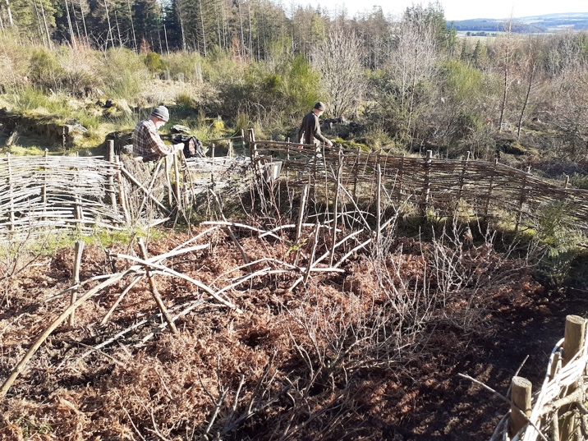 | - More fence repairs could be done – horizontal branches where fence has become lower and broom can also be used. Perhaps a task for another social visit a bit later in the year?  - Check on currant bushes to see if any branches are not productive any more, can be pruned if so. They generally look good though.  - Keep an eye on the rhubarb to see if it is more productive this year, though no sign of much yet.  - Possibility of further planting – perhaps try some swedes in between two of the rows? This would need seeds, sowing, potting on etc before planting out at the kailyard, but once they are planted they would be low maintenance.  - Around the kailyard – cut back the rest of the broom on the south side which was shading part of the kailyard (will need hand saw). We could consider further clearing broom etc from the side of the kailyard towards the main path too.
March | Barry Foster | 21/3/24 | Everything seemed fine there so not much for me to do actually, apart maybe from putting a few Laurel branches across the top of the fence by the gate where it looked like somebody had leaned on it and broken a couple of the (admittedly) rather weak pieces.  The rhubarb is showing two more leaves, (although you need a magnifying glass to see them!!) and some of the Blackcurrants are showing some leaf. | The sign board could be re-varnished and text updated. Barry to look at that with Jo.  Further planting – Colin S has given Jo some locally sourced kale seeds which have sprouted nicely and are now growing on, hopefully ready for planting out a bit later in the year.  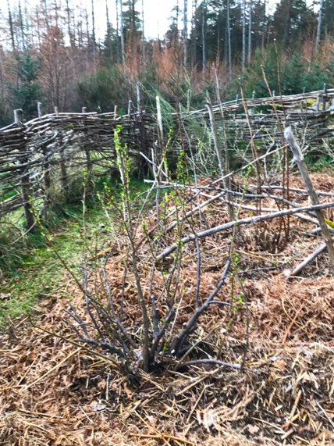
April | Andrew Wainwright | 21/4/24 | All looking good except for the rhubarb which is still tiny. I really have no idea what could be wrong with it, perhaps just the wrong soil type. I tool some of the large bits out of the black currents. With mine here I find it best to take out all the old wood so that the plants spring from the very base of the plants. Some of what I took out was quite dead and some even rotten, so probably needed to go. The lonesome current in the NE corner is looking a bit odd; branches on one side but not on the other. However the sprouts all look healthy.  + Barry and Chris have sorted out the sign, thanks to them. | Sorry for no photo from the kailyard this month, however, Colin S’s local kale is doing okay – not too far from planting out at the kailyard? Will need some tips on how to keep pests away!  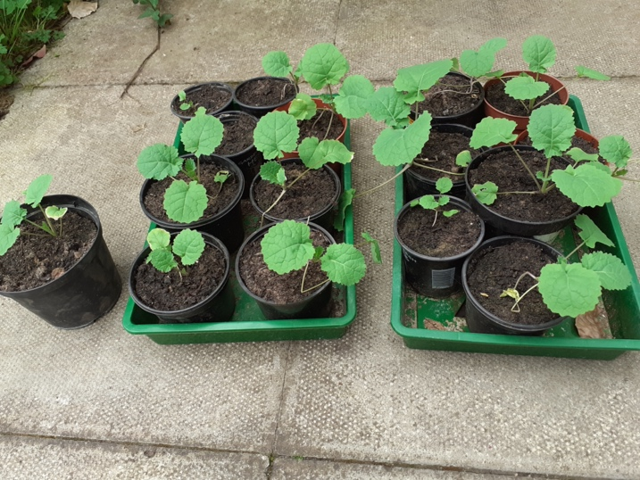
May | Jo, Jeff and guests Sara Williamsson and Greer Jarrett from Lund University. | 24 May | All looking good although gooseberries at the lower end are not in leaf. The redcurrant in the NE corner seems to be recovering with plenty of new growth.  We did the weeding and planted out the kale. | 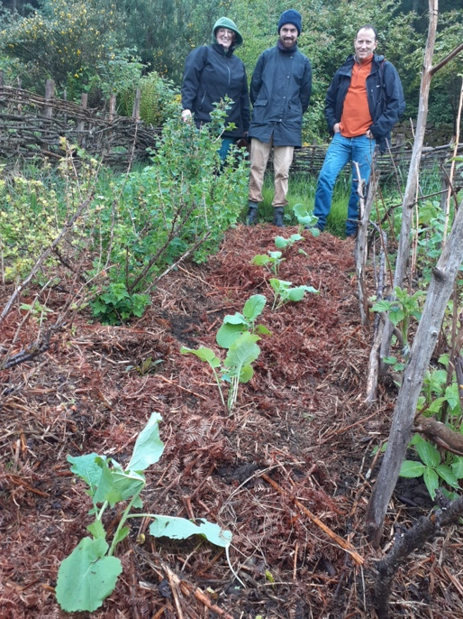
June | Jackie Cumberbirch (plus Jo) | 27 June (Jackie) 29 June (Jo) | Blackcurrant bushes laden with fruit and so are redcurrants bushes...underneath lots of small blackcurrant plants which left.  Raspberry some deaths although coming away (see photo) with regenerating blackcurrant.  Kale ok, some caterpillar or slug damage.  Gooseberries one plant great...one dead but one branch coming back and middle of base growing away well old branches dead.  Redcurrant ok.  No sign of rhubarb  Work completed:  Minimal weeding, pulled up bracken frongs and elder regeneration. Overall bracken mulch doing well.  Suggest next visit early July and harvest redcurrant, gooseberry and blackcurrants... perhaps we have a communal pick?  Also note  Unfortunately I didn't have hand saw but need to cut back small regenerating trees in Shepherd Lodge buildings and on wall.  Report from Jo:  Cut the grass around the border and around the gate. | 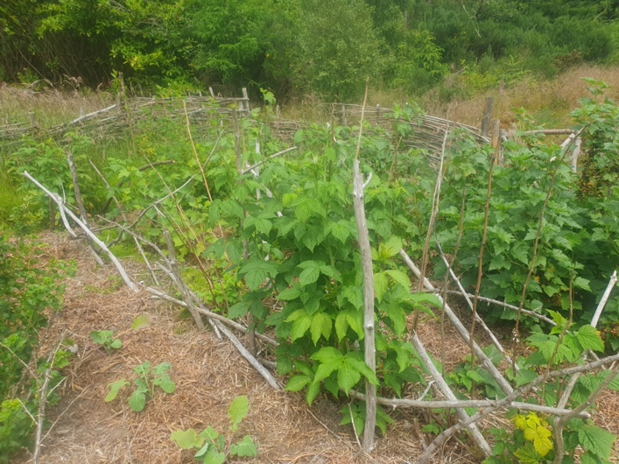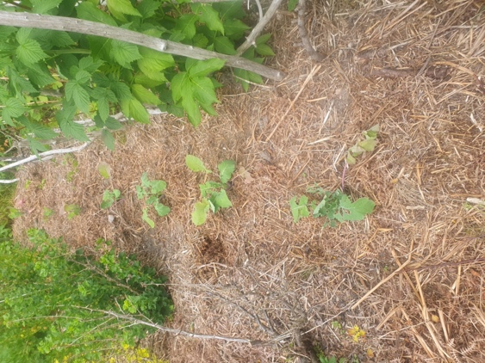  We could have a meet up in July to harvest berries and look at any other work.  Need to consider what’s happening to the gooseberries – disease?
July | Group effort (Colin M, Barry, Chris and Penny and Jo) | 27 July | The currants have all done well with good crops of blackcurrants and whitecurrants in particular, some of which were harvested (plenty left). Something has been eating the leaves but the fruit has been good. There is plenty of new growth on the middle gooseberry but the one at the bottom of the row seems to be nearly completely dead. Gooseberries from the other bushes were harvested.  The kale has been eaten down to the ground and it looks like a deer has been in. One or two of the raspberry canes have also had leaves eaten. Barry has covered the remaining kale plants with some broom to see if it will regrow.  We also weeded, did some fence and gate repairs and removed some of the nearby broom from around the kailyard and Shepherd’s Lodge.  A very nice sociable afternoon despite the rain and midgies! | 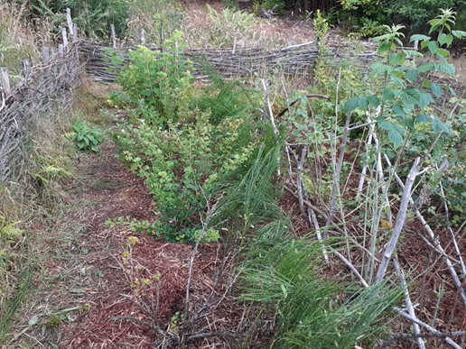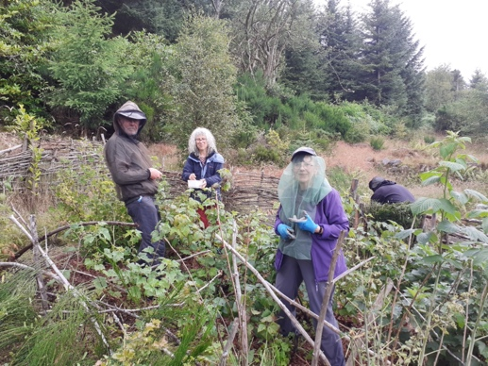  Think about a replacement for the gooseberry.
August | Anne Reid | 8/8/24 | Everything was looking good apart from the rasps which had been stripped & eaten.  The ‘dead’ gooseberry is growing new shoots from the base. The kale is growing nicely under the very effective broom barrier.  Most of the fruit is finished apart from some white currents.. much sweeter than the reds although they don’t look as nice!  I cut the grass & did some weeding.  My 7 year old grandson came with me. It was so encouaging as he knew about the colony as he’d been there several times on outings from Old Rayne school led by Alison Sutherland. He was very excited about being allowed into the kailyard! | 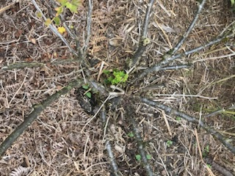  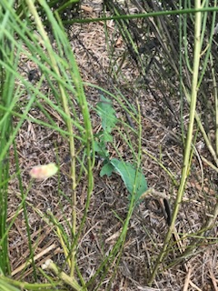
August | Anne Reid and Cathy Guthrie | 19/8/24 | Everything was looking good and there had been quite a lot of new growth since I last visited. The summer rasps are recovering from being eaten & the autumn rasps are forming fruit. All the rest of the soft fruit looking fine & all the berries are finished. More new growth from the base of the dead gooseberry.  There is also a wee gooseberry growing where the rhubarb was.. I left it!  The kale is continuing to grow.. the broom protection is great!  Cathy & I trimmed the grass, cut out the dead / fruited rasp canes, did some pruning and weeding. | Job for September.. take some loppers to cut out the dead branches of the gooseberry.  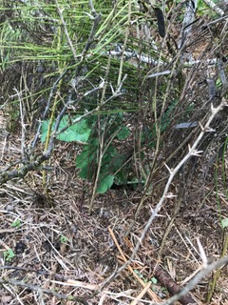  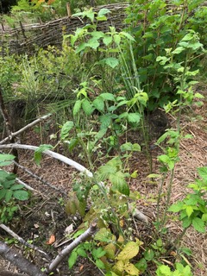
September | Allan Will | 13/9/24 | Fruit has been picked.  The leaves on the plants have holes nibbled through.  There was a random raspberry plant sprouting up on the bottom left hand corner.  The Kale was still looking good under the broom umbrella.  Everything was looking well pruned, so I weeded and cut the grass.  Shepherds Lodge in general was looking a bit scruffy, so will see if I can direct some resources to get it tidied up a bit. | 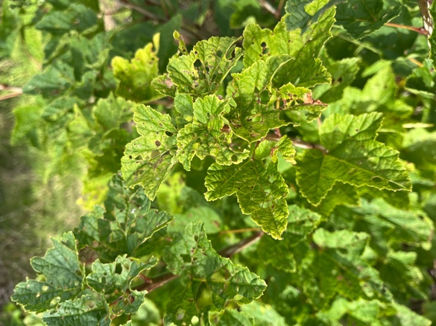  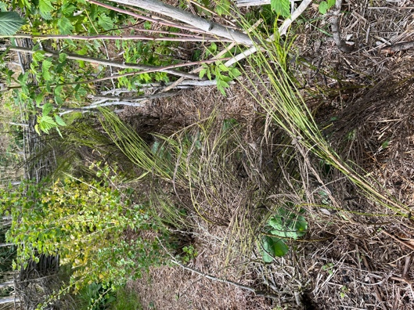
October | Alison Kennedy | 17/10/24 | Gorgeous day on hillside at any time of year, but especially for October, and not a midge in sight! In the kailyard currant foliage is dying back. There were a few straggler rasps but not worth picking, foliage on them was still looking green. There are a few rasp suckers appearing outwith kailyard fence. No gooseberries left and foliage is starting to die back for autumn. Something (bug) has been eating one of the kale plants but is still looking reasonable, while other kale plants are looking strong. Fence okay – a couple of the laurel fence posts (twigs) used to rebuild the fence earlier in year have now self-rooted and are showing some lovely growth! | 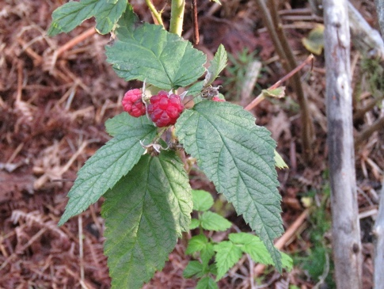  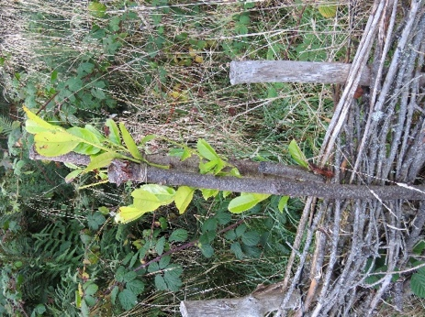
November | Chris Foster

